**Task 5:**

JavaScript is an object-oriented computer programming language commonly used to create interactive effects within web browsers. [Oxford Dictionary]

An embedded script is JavaScript code in an HTML file. In my code I have embedded JavaScript between the HTML <script> and </script> tags. Below is an example from my task 4 code.

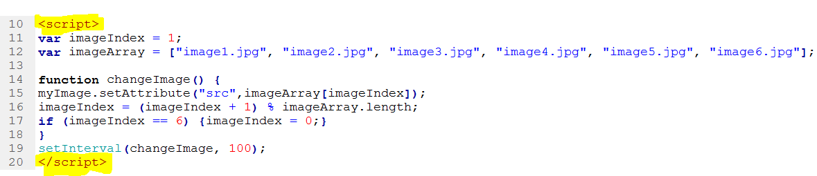

Advantages of embedded JavaScript:  
You can embed the script in the head or body tags of the HTML code and keep the webpage all in one file. It is also faster because the page loads the webpage as one object.

Disadvantages of embedded JavaScript:   
It is harder to maintain and it can be slightly slower for the browser to load, because it has to compile and execute the JavaScript as well as the HTML webpage.

Externally saved scripts  
Externally saved scripts are a different file in the HTML with the extension **.js**. They are then embedded into the HTML (shown below). [w3schools]

<!DOCTYPE html>  
<html>  
<body>  
<script src="myScript.js"></script>  
</body>  
</html>

Advantages of external scripts  
It separates HTML and code making the JavaScript easier to maintain. The JavaScript file remains cached by the browser, speeding up the page load times. It also makes the code smaller, making it easier to spot mistakes. [Stackoverflow discussion]

Disadvantages of external scripts  
The browser has to make an extra HTTP request to get the JavaScript code. The code can be download using the url of the file and this makes it easier for other people to steal your code.

Discuss the benefits of both ways to use JavaScript

All scripts should be external. For maintenance and performance. Performance is better because the code is separate it can be cached by browsers. If there are special characters in the JavaScript (like < or >) it creates problems with the HTML. It is better to use embedded code if you are only doing a few lines of JavaScript that are specific to the page then it is more convenient than doing an external file.   
[stackoverflow deduction]

In my tasks, I have used embedded scripts because I am only using a few lines of JavaScript and the benefits of an external script would have been useless.